# **Job Opportunity Investigations**

My dream is to become a great programmer and successful businessman. As I have just completed 2nd year of BSc (Hons) computing, I have gained lots of skills in web development, programming language like python and java, databases like SQL, Mongo DB, Graph DB, Casandra DB, etc. I have also gained working experience before and after I started my bachelor's. I have worked on web development with the Uplift company. Recently, I have worked on a group project called GharDailo Home to Home Service, and from this project, I got to know about lots of important things. I mainly looked at the admin dashboard development and documentation part of this project. This project gave me knowledge about external factors that impact a project like a stakeholder analysis, business canvas model, pestle analysis, mission and vision statement, risk analysis, and issues log, ethical consideration, etc. I was able to enhance my programming skill like Django, HTML, CSS, JavaScript, Bootstrap, Gitbas codes and learn to use Github Desktop and Adobe XD. The skills and knowledge that have got and learned encourage me to apply for the gobs like web development, python developer, java developer, database developer, full-stack developer, etc. Some companies that have job opportunities are mentioned below.

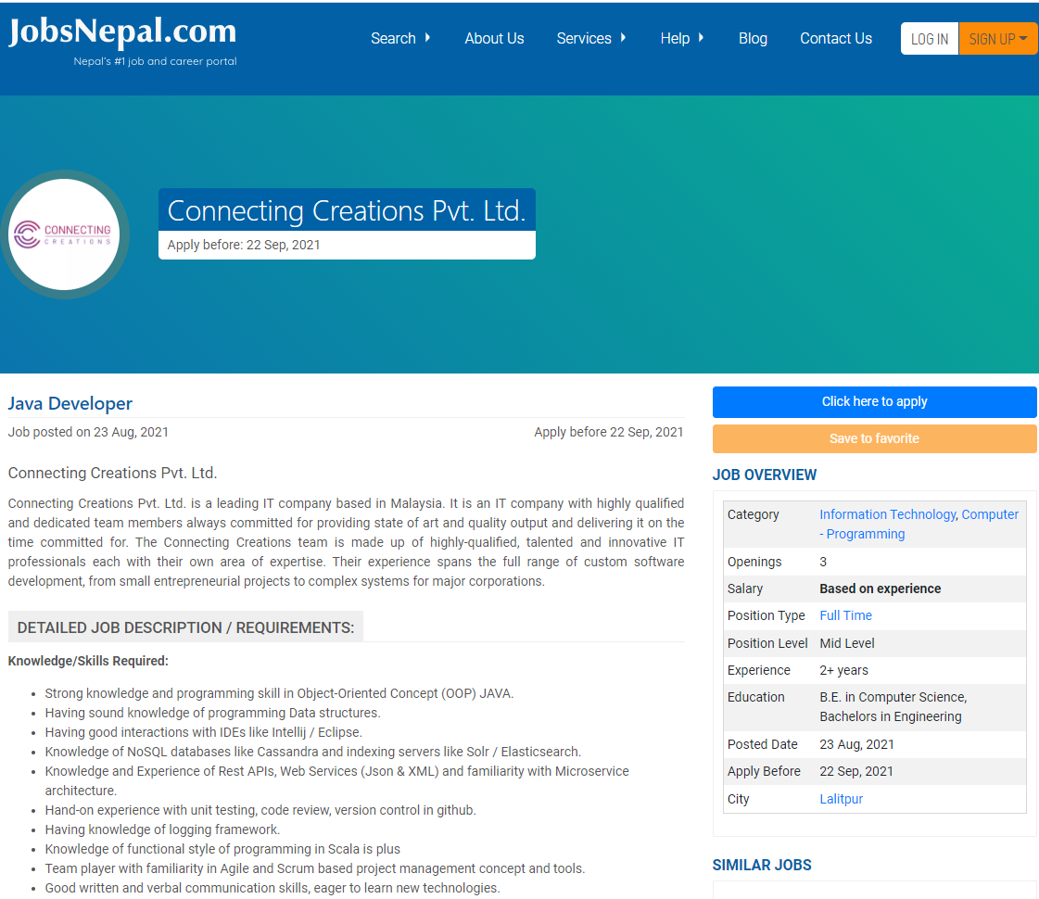

Figure 1: Java Developer at Connecting Creations Pvt. Ltd (JobsNepal, 2021).

Connecting Creations Pvt. Ltd. is a Malaysia-based IT company. The team members of this company are innovative and expert IT professionals which are talented and highly qualified. The team has experience from small projects, custom software development to complex systems. The team delivers quality products on the committed time without any delay (JobsNepal, 2021).

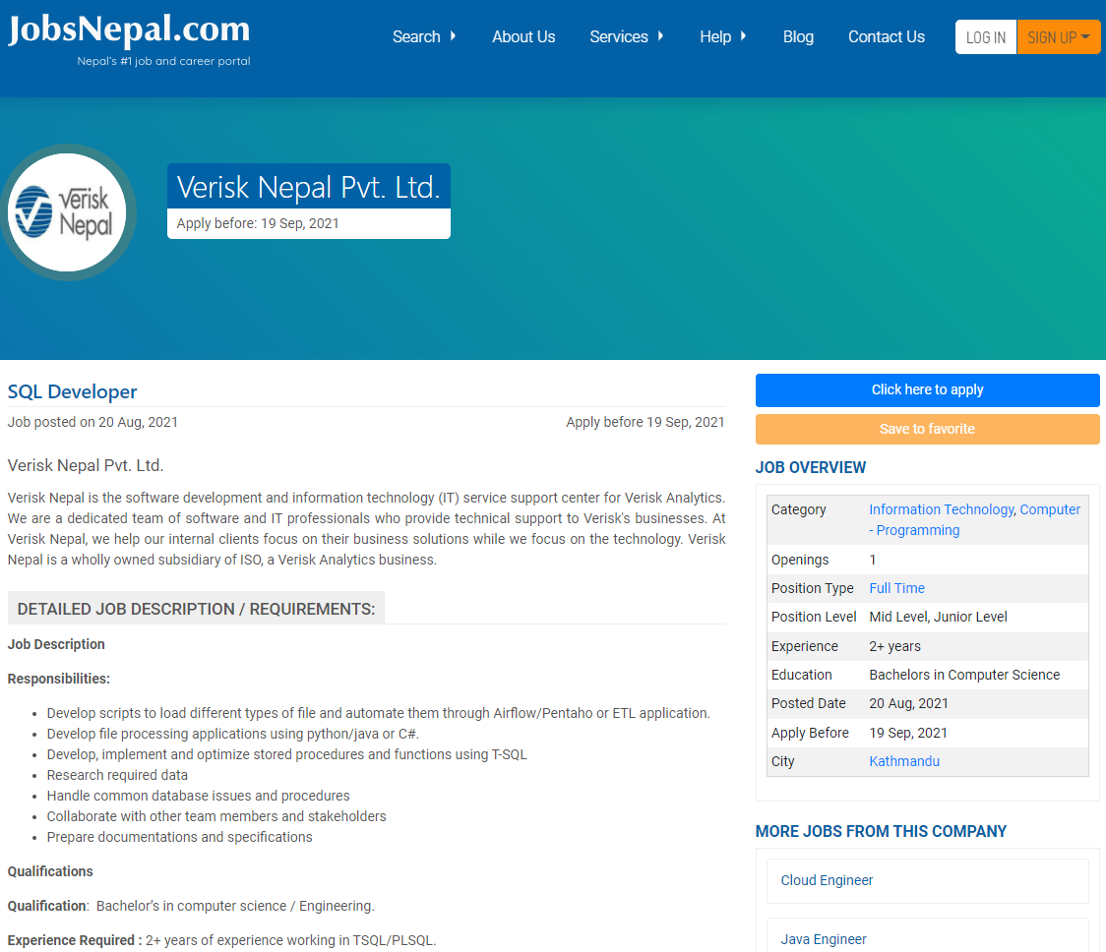

Figure 2: SQL Developer at Verisk Nepal Pvt. Ltd (JobsNepal, 2021).

Verisk Nepal Pvt. Ltd. is a software development company that focuses on insurance, services, and financial software. It is a Verisk Analytics business and information technology service support center for Verisk Analytics. Verisk Nepal started to deliver services in 2009. It considers its client’s requirements and objectives from all perspectives. It delivers services like software and application development, User interface and user experience design, data processing, analysis, and reporting, software quality control and test automation, 24/7 infrastructure and IT support, business operations support, and virtual risk assessment (Nepal, 2021).

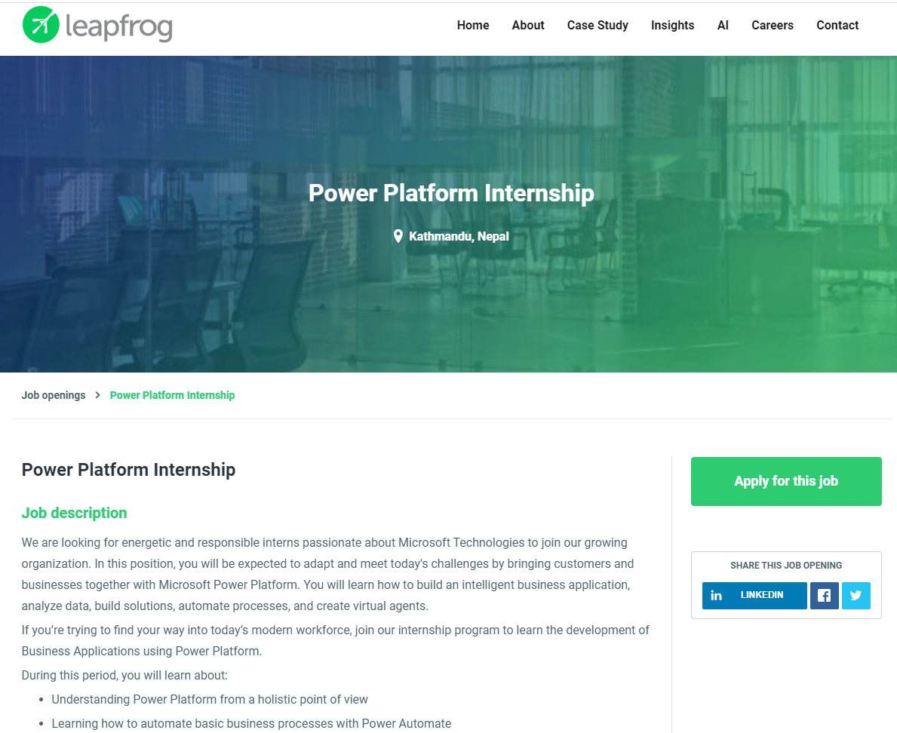

Figure 3: Power Platform Internship Leapfrog Technology Inc (Leapfrog, 2021).

Leapfrog is a well-known IT company working with its clients since 2010 in Nepal. This company builds software and cares about the quality of products, the impact of their work, who they work for. Their team is highly talented and qualified. Their mission is to solve big problems by enabling people anywhere and their vision is to generate world-class important ideas for immediate impacts. With their 10+ year of experience, 100+ satisfied clients, 200+ projects delivered, and 250+ experts, they believe that their customers choose them because of their faster working, better designs and builds, validation of the new idea, etc. The core values of Leapfrog company shared by their 250 brilliant Leapfroggers which impact communities, industries, ecosystems are Customer Focus, Transparency, Accountable Freedom, Be Remarkable, Celebrate Efforts, Compassionate Equity, Alwasybe Learning, Safe Space, Openness, Mutual Respect (Leapfrog, 2021).

SQL, database design, modeling, good communication and team working ability, javascript programming language knowledge, learning and improving willingness, should solve problems by coding or by other alternatives, etc. are the job requirements. These requirements perfectly match with my knowledge and skills and I believe that I am qualified for being the candidate for this job. This job can be applied by simply navigating on the Leapfrog company's website and then we need to provide our details along with our CV, answer some questions related to this field, and as per the job requirements. After this, there might be a written exam and an interview if the company is interested in us.

All the companies mentioned above are good in their ways. However, getting a job at Leapfrog company will be great for me because the requirement of the job matches my knowledge and skills and I will also have a chance to enhance my ideas and skills in the real-world environment. Not only this but it will also give me other skills like communication, team management, time management, healthy conflicts management, straightforward and focused, etc.

# **References**

JobsNepal, 2021. *JobsNepal.com.* [Online]   
Available at: https://www.jobsnepal.com/java-developer-121343  
[Accessed 24 August 2021].

JobsNepal, 2021. *JobsNepal.com.* [Online]   
Available at: https://www.jobsnepal.com/java-developer-121343  
[Accessed 24 August 2021].

Leapfrog, 2021. *leapfrog.* [Online]   
Available at: https://career.lftechnology.com/o/power-platform-internship  
[Accessed 24 August 2021].

Leapfrog, 2021. *leapfrog.* [Online]   
Available at: https://www.lftechnology.com/about-us/  
[Accessed 24 August 2021].

Nepal, V., 2021. *Verisk Nepal.* [Online]   
Available at: https://verisknepal.com.np/  
[Accessed 24 August 2021].